Contents

**Getting started with Clappigames C.coin Revenue** 2

**Log in to CCR** 2

**Change Password** 2

**Take a Tour of the CCR Interface** 3

**Overview of the CCR dashboard** 3

# **Getting started with Clappigames C.coin Revenue**

Welcome to Clappigames C.coin Revenue (CCR), where you can check revenue of your game in Clappigames Platfrom, in real-time and in one place, helping you to update your revenue in game, faster

CCR is built for the browsers, so you can use it across any platform (Window, Mac, Linux and Chromebook).

1. Browser and operating system requirements

CCR runs well on most browsers.

The minimum browser requirements are:

* IE9, IE10, IE 11, Edge
* Firefox: 51+
* Chrome: 49+
* Safari: 10.1+

1. Using CCR on Mobile Devices

The minimum requirements to use on mobile browsers are:

* Safari on iOS 10, 11, 12
* Chrome on Android 7.0 – 9.0

# **Log in to CCR**

There is only a method to log in to your account. You will receive username and password from Clappigames staff via Email when you sign contract with Clappigames.

Log in with your username and password

1. Enter link into browser: partner.clappigames.com
2. Enter your username and password in the field provided
3. Click Sign in to complete the process and access your account

*Forgot your Password?*

1. Contact with Clappigames staff to notice that you forgot your password
2. Clappigames staff will send to you a new password
3. Log in CCR with your username and new password

# **Change Password**

You can change your password in menu top-right corner

1. Enter your old password and new password in the field provided
2. Click Change Password button to complete the process
3. Next time when you sig in to CCR, you must have to use new password.

# **Take a Tour of the CCR Interface**

## **Overview of the CCR dashboard**

There are three main sections

* Navigation bar
* Left Chart illustrate line chart about Purchase of game, default last 7 days.
* Right Chart show Revenue total and percentage of device sources used in payment, default last 7 days.

## ***Navigation bar***



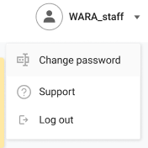

The navigation bar contains logo Clappigames and menu personal. From left to right we have

Logo Clappigames

When use stand every page of site, you can come back dashboard if you click this logo.

Menu personal

The menu contains change password function, support page, and log out function. Like the logo Clappigames, menu is fixed on top of site, you can choose what function if you want to do.

## ***Left Chart***

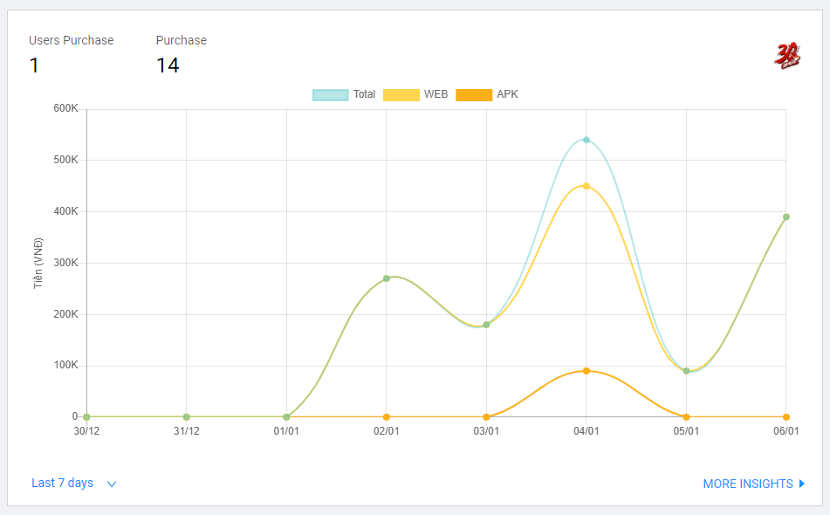

The chart allows you to see:

* The total amount of user makes payments
* The total amount of purchase
* In line graph show how the revenue of game have changed by 3 lines: total, web, APK file for last 7 days default. Unit money is VNĐ.

You can choose timeline to show revenue.

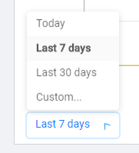

* Today

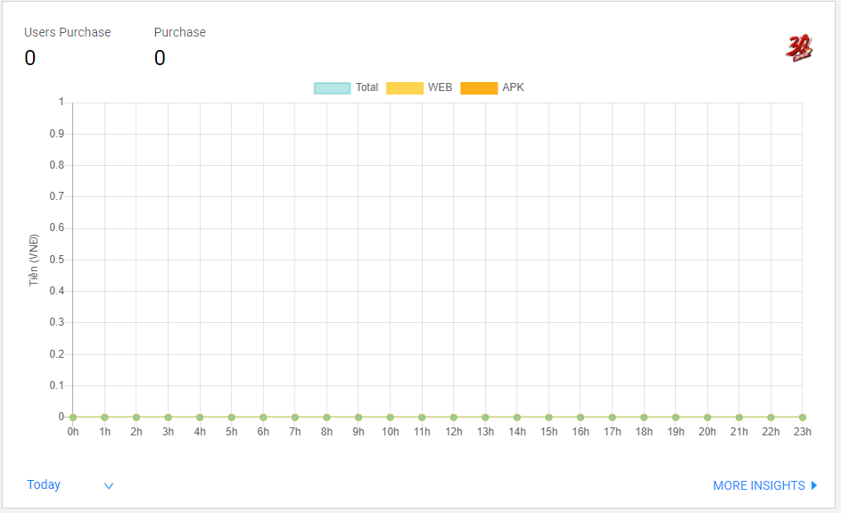

* Last 7 days
* Last 30 days

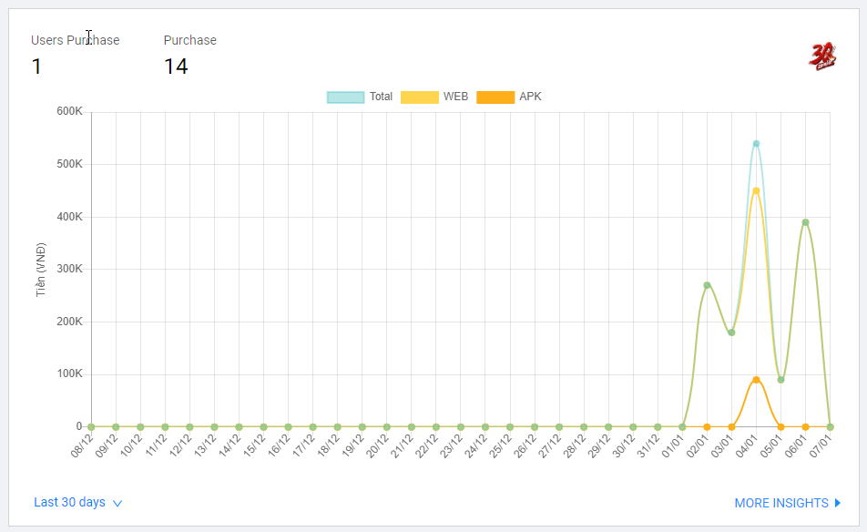

* Custom

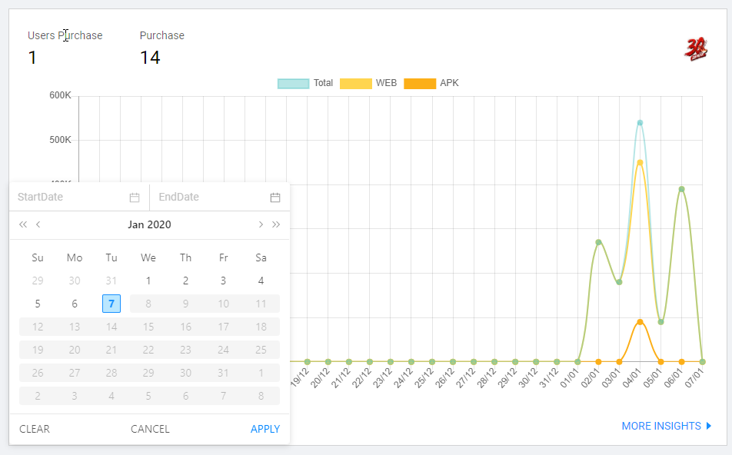

*If you want to get list revenue for more 30 days, please contact with us. Clappigames staff will help you to see via document*

When you want to see more insights about name products, time, username bought, … please choose **MORE INSIGHTS** button.

## ***Right chart***

The CCR UI allows you to see about Total Revenue of game and percentage of platform where user purchase.

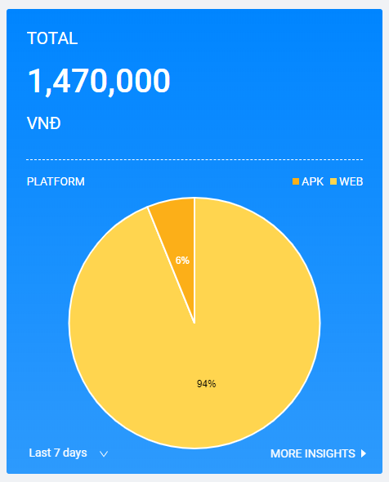

# **Woking with data details**

## ***Overview of Data details***

Data details show more insights of data. We provide further details of a purchase and allow you use some feature to do with data.

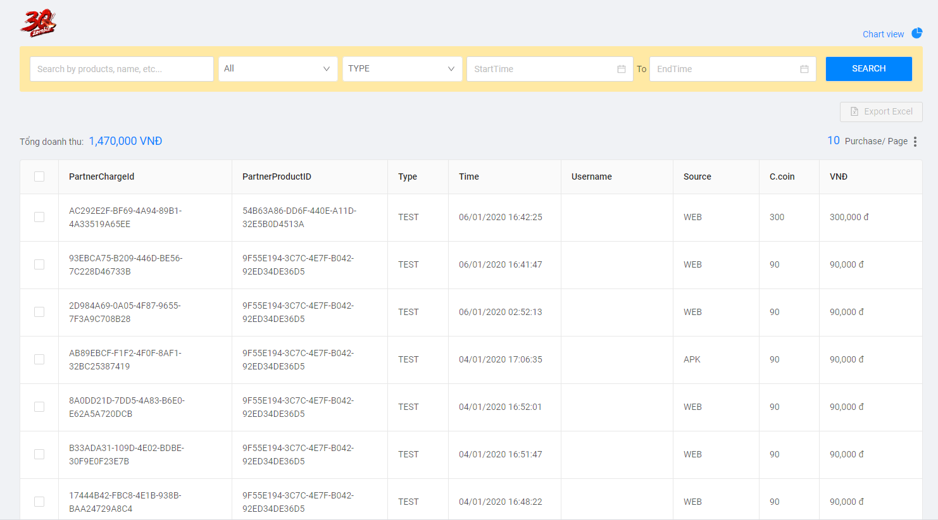

A purchase contains Product name, ID product, ID Purchase, Time, Username who buy, Source, Price exchange to C.coin and Price exchange to VNĐ.

When you wanted comeback chart view, choose chart view button on the top-right.

## ***Search for Purchase***

You can look for Purchase using the Search function on top.

To search for a purchase:

1. Type Product name, select start time to end time
2. Press search button. As you type, we will show the search result in the table below
3. We sort any result by last time

## ***Export Excel***

Export in Excel format

To export your data from CCR you need to make your selection. After you select purchase, then export excel button will be able.

You can select which purchase you’d like to export. This could be:

* A single purchase
* A list purchases

## ***Show up to***

We support you to see the number of Purchase if you want.

* 10 Purchase/page
* 20 Purchase/page
* 50 Purchase/page

